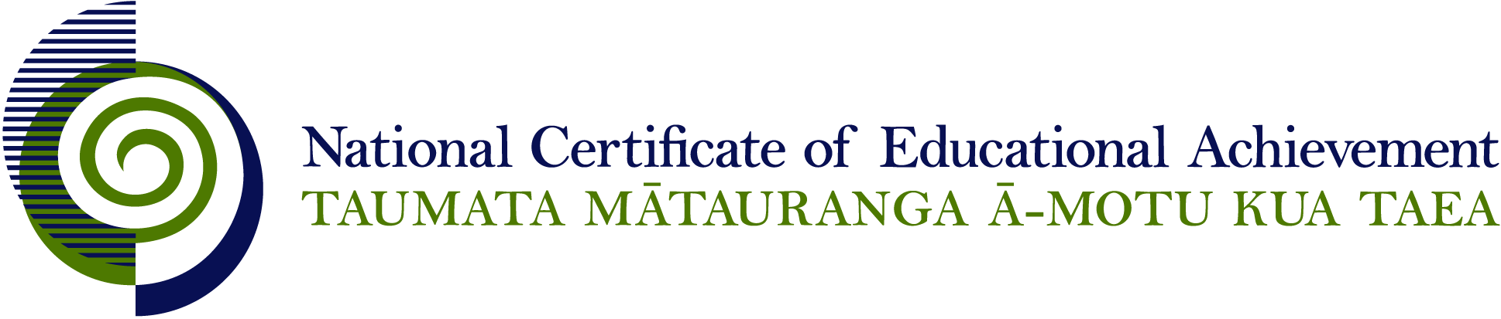

EXPIRED

NCEA Level 1 Visual Arts

Conditions of Assessment

General Information

Subject Reference | Visual Arts
Domain | Practical Art
Level | 1

This document provides guidelines for assessment against internally assessed standards. Guidance is provided on:
- appropriate ways of, and conditions for, gathering evidence
- ensuring that evidence is authentic
- any other relevant advice specific to an achievement standard.

NB: It is expected that teachers are familiar with additional generic guidance on assessment practice in schools published on the NZQA website. This should be read in conjunction with these Conditions of Assessment.

For All Standards

Internal assessment provides considerable flexibility in the collection of evidence. Evidence can be collected in different ways to suit a range of teaching and learning styles and a range of contexts of teaching and learning. Care needs to be taken to allow students opportunities to present their best evidence against the standard(s) that are free from unnecessary constraints.

It is recommended that the design of assessment reflects and reinforces the ways students have been learning. Collection of evidence for the internally assessed standards could include, but is not restricted to, an extended task, an investigation, digital evidence (such as recorded interviews, blogs, photographs or film) or a portfolio of evidence.

It is also recommended that the collection of evidence for internally assessed standards should not use the same method that is used for any external standards in a programme/course, particularly if that method is using a time bound written examination. This could unfairly disadvantage students who do not perform well under these conditions.

A separate assessment event is not needed for each standard. Often assessment can be integrated into one activity that collects evidence towards two or three different standards from a programme of learning. Evidence can also be collected over time from a range of linked activities (for example, in a portfolio).This approach can also ease the assessment workload for both students and teachers.

Effective assessment should suit the nature of the learning being assessed, provide opportunities to meet the diverse needs of all students and be valid and fair.

Where manageable, and after further learning has taken place, students may be offered a maximum of one further opportunity for assessment against an assessment standard within a year.

Authenticity of student evidence needs to be assured regardless of the method of collecting evidence. This needs to be in line with school policy. For example, for an investigation carried out over several sessions, this could include teacher observations or the use of milestones such as meetings with students, journal or photographic entries recording progress etc.

Specific Information for Individual Internal Achievement Standards

Achievement Standard Number | 90913 Visual Arts 1.1
Title | Demonstrate understanding of art works from Māori and other cultural contexts using art terminology
Number of Credits | 4
Version | 4

Evidence may be presented by the student in a range of forms, including:
- annotated drawings, photocopies and diagrams
- oral presentations
- written paragraphs
- data display presentations
- audio recordings
- visual recordings.

Where possible, students should have the opportunity to investigate cultural contexts that are relevant to their own cultural milieu.

Achievement Standard Number | 90914 Visual Arts 1.2
Title | Use drawing methods and skills for recording information using wet and dry media
Number of Credits | 4
Version | 3

Evidence may be submitted in a range of modes, including:
- hard copy
- digital still image
- digital moving image
- 2, 3 or 4 dimensional
- audio visual.

Achievement Standard Number | 90915 Visual Arts 1.3
Title | Use drawing conventions to develop work in more than one field of practice
Number of Credits | 6
Version | 2

When referring to established practice a range of examples of artworks should be referenced with regard to the genre, style, convention or way of working.

Work should demonstrate the characteristics and constraints of more than one field. Where fields are combined into a single work the evidence should demonstrate the conventions of both fields.

Evidence may be submitted in a range of modes, including:
- hard copy
- digital still image
- digital moving image
- 2, 3 or 4 dimensional
- audio visual.

Achievement Standard Number | 90917 Visual Arts 1.5
Title | Produce a finished work that demonstrates skills appropriate to cultural conventions
Number of Credits | 4
Version | 3

Where collaborative or group projects are undertaken strategies need to be developed to facilitate the assessment of individual learners. This may include:
- designated roles and/or parts within a group project
- a tracking system to monitor individual contributions, e.g. a log of teacher observation
- teacher observation and teacher/student conferencing can be used to verify individual student’s contribution to the collaborative process
- production diary noting individual contributions to the project
- peer assessment, used in conjunction with teacher input
- limiting group numbers, depending on the context

Evidence may be submitted in a range of modes, including:
- hard copy
- digital still image
- digital moving image
- 2, 3 or 4 dimensional
- audio visual.

